**Data Visualization Project**

**Index**

* **Introduction ……………………..………2**
* **Explaining the data……………..……..3-4**
* **Ideas and planning………………..……5**
* **Our Solution………………………..…..6-7**
* **Pre-Processing…………………….……8**
* **Interactions……………………………9-12**
* **Writing the Code……………………….13**

1. **Introduction:**

**Link to Project:** [**34.66.22****3.151/~a29/Final/index.html**](http://34.66.223.151/~a29/Final/index.html)

Greenhouse emissions are becoming more and more of a problem, record-breaking warming happen year after year, this year on base to become the hottest ever measured year, cutting methane across the oil and gas sector is the quickest and most cost-effective opportunity we have to slow the problem down now.

It is estimated that methane accounts for about 25% of current warming, fortunately, there are many simple proven strategies to reduce these emissions, these strategies can shrink methane emissions by 50% in the coming few years, this could deliver the same short term climate benefit as closing one third of the world’s coal-fired plants, therefore countries must start to use these strategies to start help solving this worldwide problem.

We wanted to build a visualization that answers this questions:

1. which countries has the most methane emissions, and how much? (relative to it’s size)
2. Which sectors are the responsible for methane emissions for each country?
3. Which countries are working towards solving the problem, and which are apathetic? are we making progress?

By creating these visualizations, we can spread more awareness about methane emissions and how dangerous it can be and people all around the world can see how the methane emissions have changed in the past 30 years in all over the world.

People all around the world can use this visualization,

Having this visualization available to the public would pressure the country’s governments for a change, therefore we could see in the near feature most countries using strategies to cut methane emissions.

1. Explaining the data :

The data that we used was taken from Kaggle.com we used two datasets,

First Dataset describes the methane emissions for countries around the world

<https://www.kaggle.com/datasets/kkhandekar/methane-emissions-across-the-world-19902018>

Link to the excel file: [methane_hist_emissions.xlsx](https://campushaifaac-my.sharepoint.com/:x:/g/personal/zqubien_campus_haifa_ac_il/EUeQ7hlz8-1CuHuUFg53GOABWiHtGF2YF-zcTgplsysXjQ?e=MXBRBj) ,

The dataset includes 1739 rows that contains columns about the name of the country, what is the sector of emission type of gas, unit and it gets represented by each year from 1990 until 2018,

So by looking at this dataset we can tell for each country how much emissions it had each year since 1990 and has it gone better or worse? And to compare countries to see which countries has the most emissions and least.

But we can’t just compare countries **only** by the emissions it’s not fair for example we can see that Russia had about 853 MTCO2e in 2018 while Israel had only about 12.07 MTCO2e, so by looking at this we can see that Israel is doing much better than Russia?

The answer is no because we have also to take land in consideration Russia is the biggest country in the world and it wouldn’t be fair just to compare it only by the unit, so we have to use Grams per KM^2 and this is how it looks. We can see that Israel’s emissions per KM^2 is way higher than Russia

So, in order for us to calculate the Grams per KM^2 we need the Area so we used another Dataset from Kaggle.com: Countries of the world.(from this Dataset we **only** used the Area (sq .m)

Link:<https://www.kaggle.com/datasets/fernandol/countries-of-the-world>  
Link to the Excel file: [countries of the world.xlsx](https://campushaifaac-my.sharepoint.com/:x:/g/personal/zqubien_campus_haifa_ac_il/EeUkTrHKi01OrmqoDe6ac8MBvcSsJFtAc56qPGD8RveRWg?e=iszmCh)

So we merged the data that we needed from countries around the world and methane emissions into a new data set which includes all of the necessary information that we need. (More on that in section 5.A)

Link to the excel file:[methane_hist_emissions (1).xlsx](https://campushaifaac-my.sharepoint.com/:x:/g/personal/zqubien_campus_haifa_ac_il/ESFhFxMYdPpClYqcDl4eWQQBvNJv4rKHyygMI0hPqcb0Sw?e=1ztZNh)

1. Ideas and planning

We started thinking for an optimal solution for every question that we had,

**First question:**

which countries has the most methane emissions, and how much?

To We started thinking about a bar chart: but then after thinking about it we quickly realized it is almost impossible to implement a bar chart that would cover almost 200 countries the bar will not look clear and efficient, so we had to think of another alternative solution, then we thought about making a bar chart for each continent but this wasn’t specific enough.  
then we came with the optimal solution which is a world map that includes all of the countries.

**Second question:**Which sectors are the responsible for methane emissions for each country?

Our first solution that came to our mind was heatmap but we didn’t want to use it again we wanted to be more creative so we realized that we could have used either a Pie chart or a bar chart and after implementing both of them it was hard for us deciding which type of chart to use but then we decided to go with bar chart because we have seen that the bar chart looked more professional and neater.

**Third question:**Which countries are working towards solving the problem, and which are apathetic? are we making progress?

In order for us to solve this answer we needed to compare the countries emissions over the years, we thought about making a line chart to show the emissions for each country through out the years but it was hard to show 193 countries in one line chart and it won’t be clear, so we decided to look for other alternatives but we didn’t find any better alternatives so we decided to further improve our world map that we created for the first problem by adding a time slot and we can filter by the year that we want and compare the countries for that specific year, but we felt also that this wasn’t so we though of making it animated(shows the progress of the bar from 1990 to 2018) but we figured that this was too hard to implement so we decided to add a line chart to our world map which can help us compare countries emissions through out the years by clicking on these countries in the map.

1. **Our solution:**
   1. Why did we choose our graphs, values and colors?

**World Map**: As we said before world map was the best graph to display 193 countries in an aesthetic way, and we added year selection to easily see the differences between each year

Values: like we said we chose to view methane emissions relative to the country’s size, that would be more fair for big countries who must emit a lot of methane to keep their country running, and we don’t get a world map where every big country has a high methane emissions where every small country has low methane emissions.

Colors: methane is a colorless gas, so we asked out self how does the methane affect our world and it rises the temperature of the earth and we know that the color red usually represents a hot temperature, therefore we used the ranges of red colors from weak to bold red to display how much the emissions in each country is, we couldn’t obviously use green for low emissions because green the opposite of red meaning it is cooling down and even a very small production of methane leads to temperature rising so that’s why we used the range from light orange to red.

Thresholds: we used top percentage as threshold because using certain numbers as thresholds was confusing for the user, top % countries was clean, easy to understand and divides the countries in 5 main categories, we decided to divide them only to 5 categories so our world map would easier on the eyes by only having 5 colors and each one Is a little bit darker then the one before it was easier to identify where each color belongs in the percentage area, we divided our categories into quarters and last two categories were top 10% and from 10% to 25%.

**Bar chart:** bar chart was really good solution to easily show the selected countries most methane emitter sector, it’s easy to understand and interactive with the world map (it shows the data of the chosen country from the world map)

Values: here we didn’t take country’s size into consideration, because it wouldn’t matter, we are comparing a country with itself therefore there’s no reason to change it.

Color: we chose this color because it goes well with the theme of the world map, and also has the same reason as the world map

**Line chart:** line chart has is the best chart to compare methane emissions over the years, it can hold multiple countries at a time for comparison, it can clearly show if a country’s emissions are increasing / decreasing / staying the same

Values**:** we decided to keep the same metric as in the world map, without confusing the user with too many metrics and comparing would be fair like we explained in the world map.

Colors: we chose colors that matches the theme of the page while also being easily distinguishable from each other.

* 1. **Pros**
* Our world map is very clear and user friendly just by looking at it we can understand which countries have the most emissions and which have the least.
* We can easily see the emissions on earth by the year.
* In the world map we can easily compare the emissions in countries by colors and we chose colors that describes the emissions in a very clear way that are similar one to another but still easy to tell them apart.
* Out graph is very interactive.
* Our Bar chart shows the types of emissions for each country and their quantity very clearly.
* Our line chart can compare the emissions countries all over the years in a clear way also by using a tool tip.
* In our line chart we can compare the data of more than one country,
  1. **Cons**
* it can take time to find a specific country if you don’t know geographic.
* The data is updated only to 2018 and not to 2022 so we don’t know if a specific country has improved their emission over the last 4 years or not.
* When we add lots of countries for comparison it can make a load.
* In the line chart we can only compare up to 7 countries for users that want to compare a large number of countries this can be inconvenient for them.
  1. **Mapping**

We used the data that we had and implemented it in our graphs, first when we open the graph we can see the world map, and the map shows data based on the year that was selected the default year chosen is 1990 but we can select another year to show the data for the specific year.

The value of the emissions is calculated using this formula: MTCO2e/ (size of country/1,000,000) it converts the value into Grams per 1 KM^2.

And when we choose a country on the map two more graphs appear a Bar chart: which shows each sector and it’s quantity in the selected country using MTCO2e, and Line chart shows the progress over the years for the selected countries in Grams per 1 KM^2 and we can hover on the tool tip to see the value in a specific year.

5. A. **pre-processing**:

We started out with only the dataset of methane emissions , and like we said earlier, without country size we didn’t get good results, the bigger the country the more emissions it had, for that reason we decided to take country size into consideration and calculate methane emissions per km^2, so we got another dataset that has information about country sizes and merged them into one, we used python to add the size columns into the methane dataset,

Code: 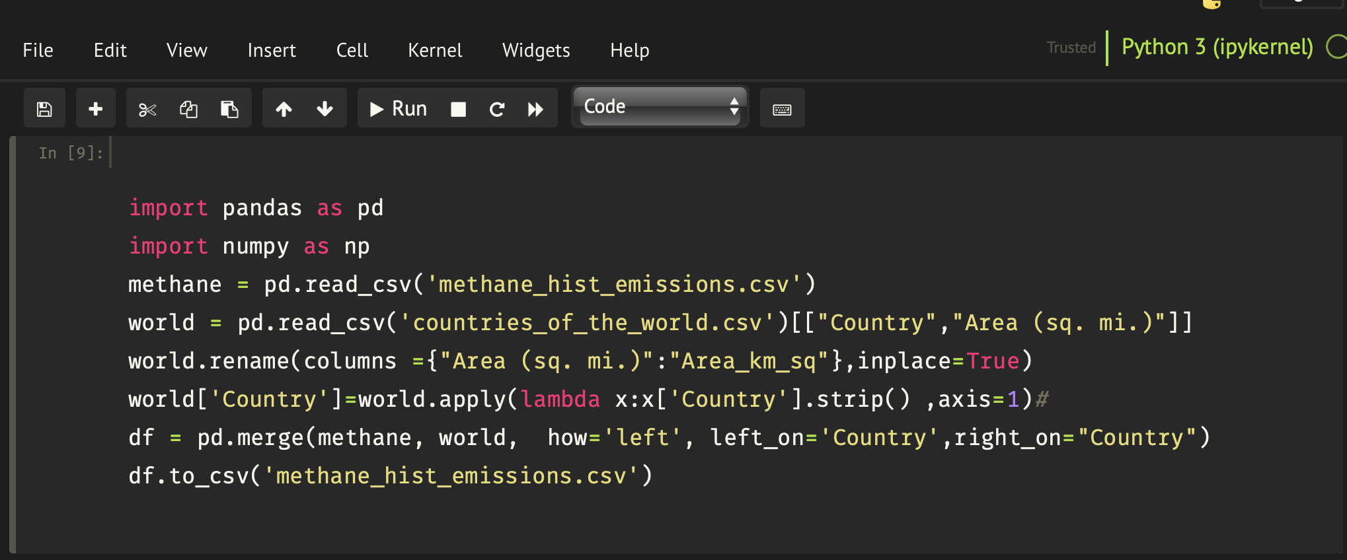

After we have done that we realized that country names aren’t the same, we didn’t find any easy way to fix this problem, therefore we were forced to enter excel and change the names manually to match and them we ran the python code again,

We faced the same problem when matching the dataset countries to the world map, our world map had a lot of missing data even though we had the data for them, names like England and United Kingdom weren’t matching, so again we changed the names manually until we had almost full world map.

5.B. **Interactions**

The visualization starts out like this:

No line chart and United states as a default country on the bar chart,

pointing on any element on the bar chart or the world map or the line chart would present a tooltip window with the relevant information on it

Pointing on a country would view the tooltip, Clicking on a certain country will zoom in to it, change the bar chart data to this specific country and add the country to the line chart

Re clicking on the same country zooms out

You can select multiple countries for comparison

You can delete either by clicking on a line’s point to delete certain country line, or by clicking the clear button to delete all country lines

You can select up to 7 lines, upon adding the 8th line you’ll get this message, it’s recommended to keep up to 4 lines at a time for a less messy chart

You can see world map based on the selected year, bar chart is also related to the year selected

You can select any year from 1990 to 2018

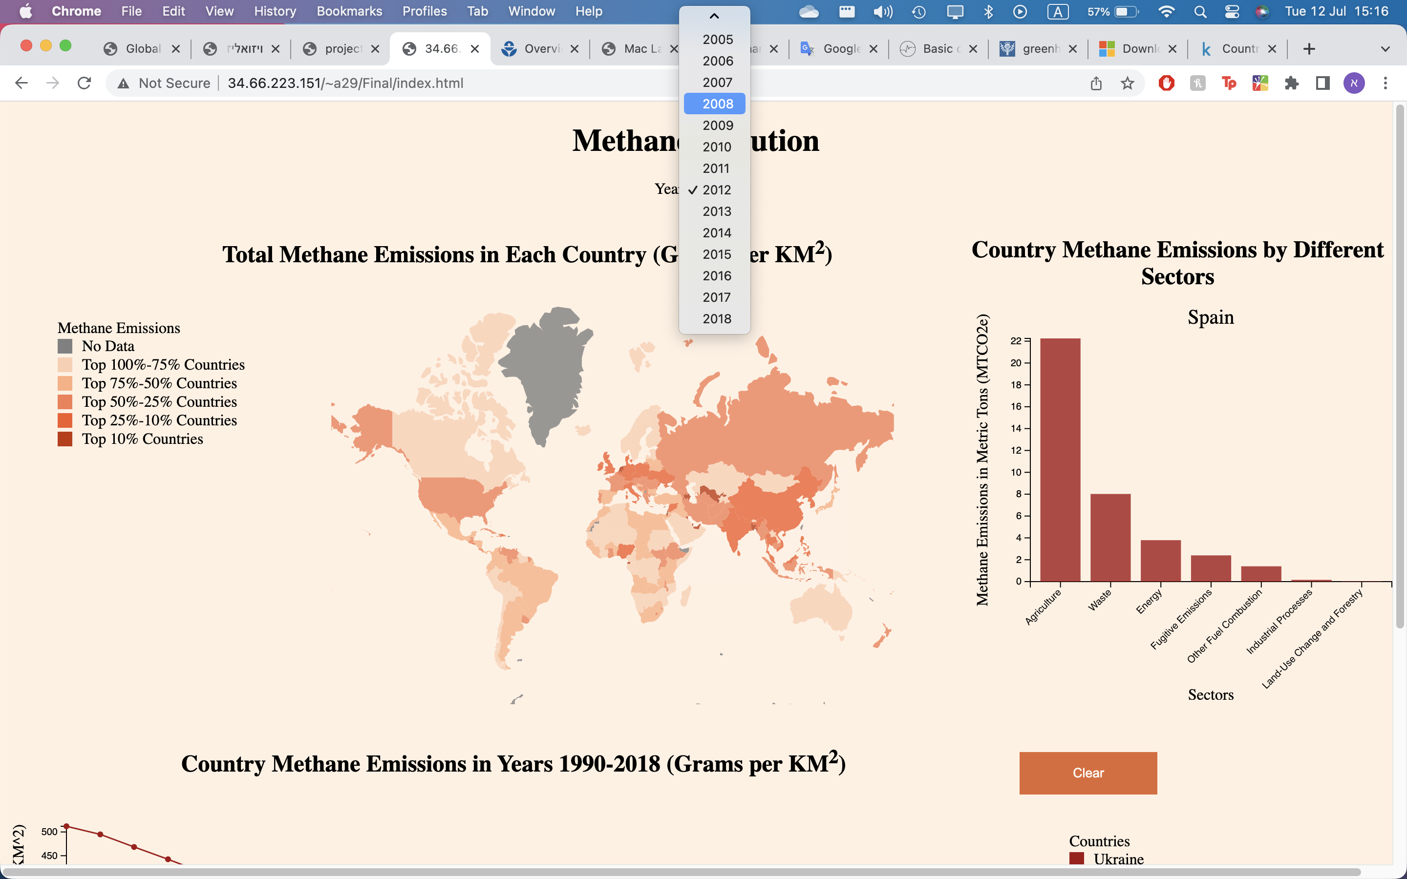

5 C. **Writing the Code:**

* File index.html-includes the html code for our project.
* Index.js includes all of the related code for java script.
* methane_hist_emissions.csv- contains all the data that we used
* globe.json- contains the world map

Libraries

* we used d3 version 6,
* we used d3-legend version 2.13
* we used d3-simple-slider

For implementing Bar chart we used this : [Simple bar graph in v7 - bl.ocks.org](https://bl.ocks.org/d3noob/08cc6159b9315e20e74a72e85a50dd3e)

For implementing line chart Line chart we used this: [Simple Line Graph v7 - bl.ocks.org](https://bl.ocks.org/d3noob/15e4f2a49d0d25468e76ab6717cd95e7)

For implementing world map we used this: [Basic choropleth map in d3.js (d3-graph-gallery.com)](https://d3-graph-gallery.com/graph/choropleth_basic.html)

For designing the legend we relied on this source: https://codepen.io/zemekovum/pen/NLzeZm

We also relied on stack overflow for implementation and fixing the bugs.